**1)**

**A = B * (C * (A + B))**

**Grammar:**

Statement 🡪 Assignment | Expression

Assignment 🡪 Identifier = Expression

Expression 🡪 Expression + Term | Term

Term 🡪 Term * Factor | Factor

Factor 🡪 ( Expression ) | Identifier

Identifier 🡪 A | B | C

**Leftmost Derivation:**

Statement

Statement 🡪 Assignment

Assignment 🡪 Identifier = Expression

A = Expression

A = Term * Factor

A = B * (Expression)

A = B * (Term * Factor)

A = B * (C * (Expression))

A = B * (C * (Expression + Term))

A = B * (C * (A + Term))

A = B * (C * (A + B))

**Parse Tree:**

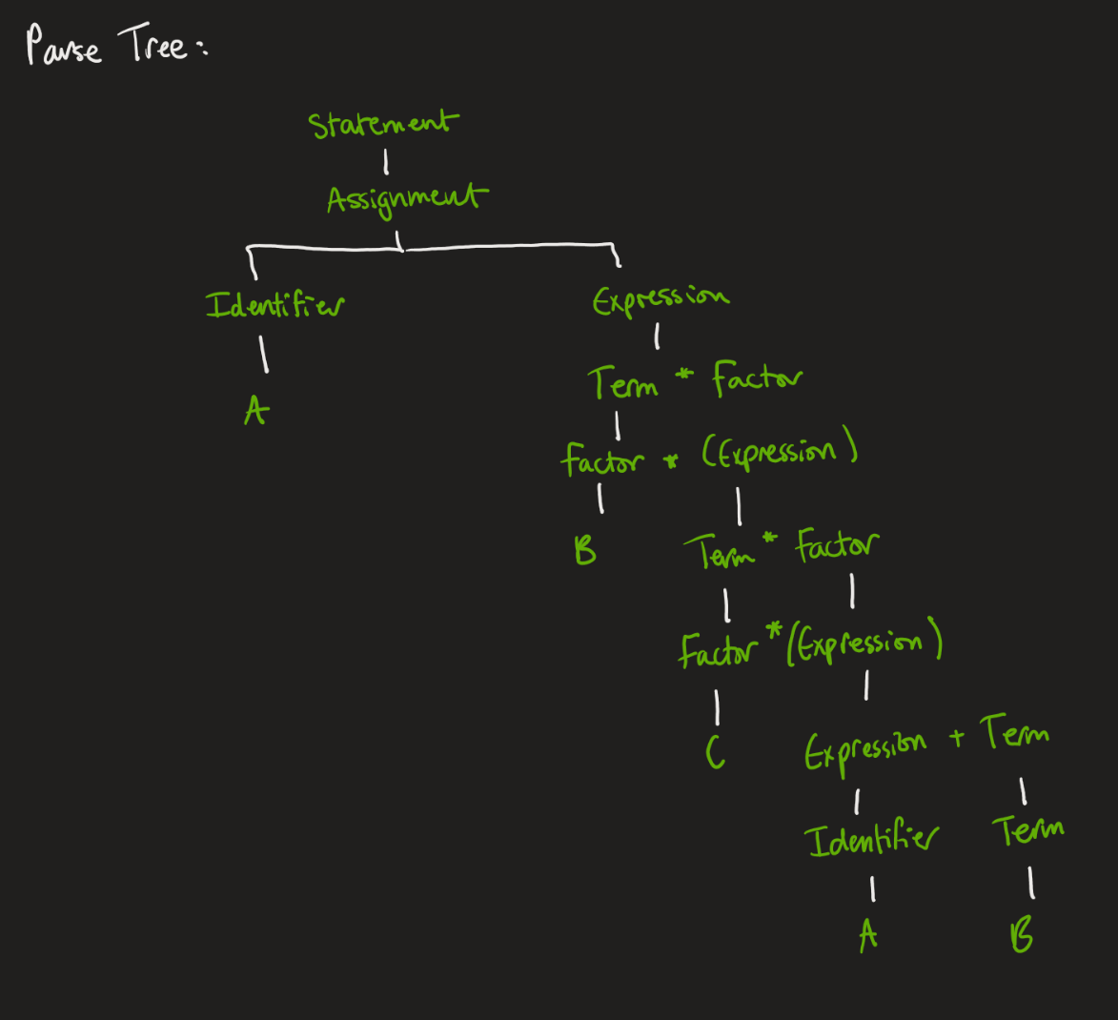

**2)**

**a)** u = 69 + 42 + 69

u = 180

prints: 180

**b)** u = 42 + 42 + 42

u = 126

prints: 126

**c)** u = 42 + 17 + 42

u = 101

prints: 42